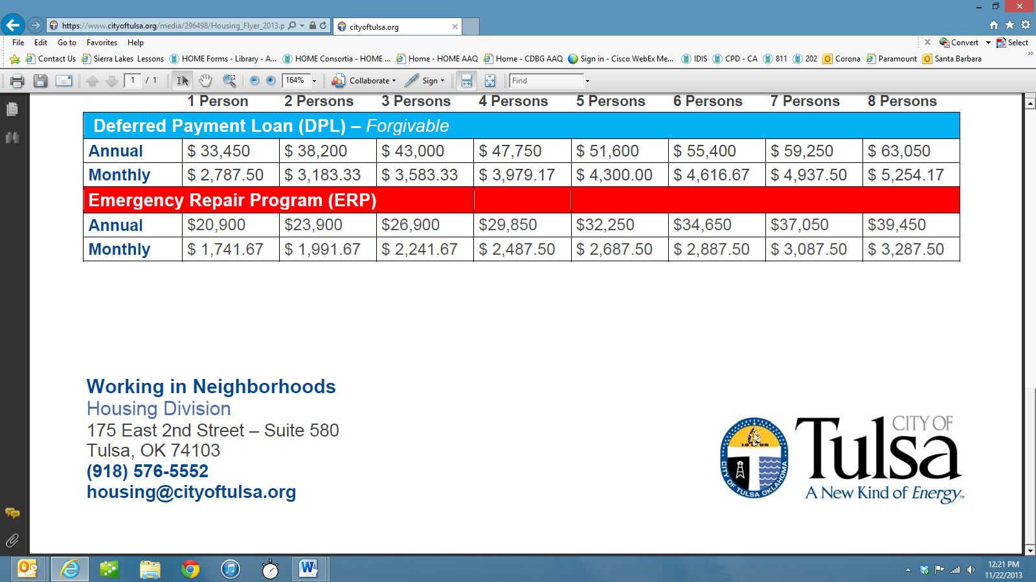

**HUD Grants: A Reference Guide**

**May 2018**

# Community Planning and Development Programs

The U.S. Department of Housing and Urban Development (HUD) office of Community Planning and Development (CPD) awards formula grants to units of local government for the implementation of four (4) programs included under the Consolidated Plan regulations found at 24 CFR Part 91.

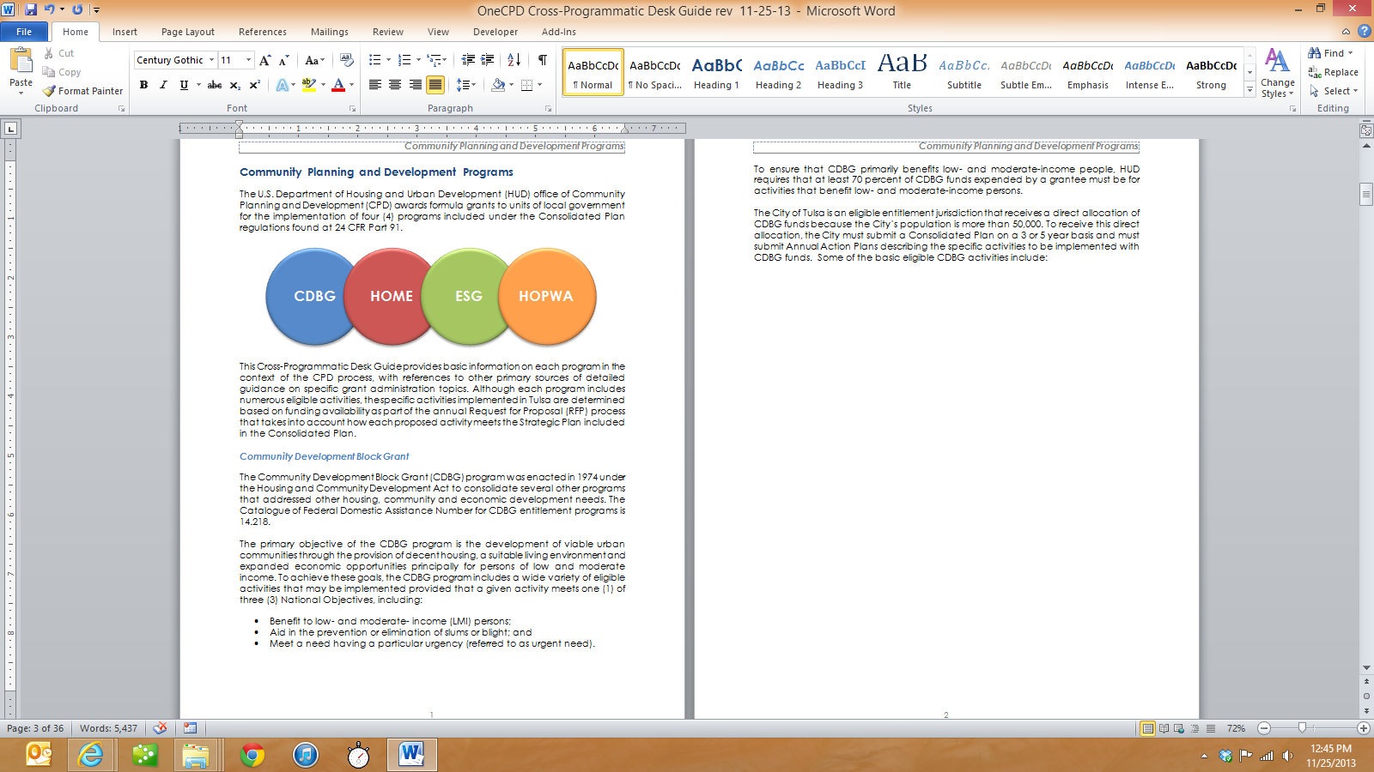

**CROSS-PROGRAMMATIC REQUIREMENTS**

This Guide provides basic information on each program in the context of the CPD process. Not included in this guide are other federal regulations that may apply, depending on the type of grant and the type of program or project. Although each program includes numerous eligible activities, the specific activities implemented in Tulsa are determined based on funding availability as part of the annual Request for Proposal (RFP) process that takes into account how each proposed activity meets the Strategic Plan included in the Consolidated Plan.

## Community Development Block Grant

The Community Development Block Grant (CDBG) program was enacted in 1974 under the Housing and Community Development Act to consolidate several other programs that addressed other housing, community and economic development needs. The Catalog of Federal Domestic Assistance Number for CDBG entitlement programs is 14.218.

The primary objective of the CDBG program is the development of viable urban communities through the provision of decent housing, a suitable living environment and expanded economic opportunities principally for persons of low and moderate income. To achieve these goals, the CDBG program includes a wide variety of eligible activities that may be implemented provided that a given activity meets one (1) of three (3) National Objectives, including:

* Benefit to low- and moderate- income (LMI) persons;
* Aid in the prevention or elimination of slums or blight; and
* Meet a need having a particular urgency (referred to as urgent need).

To ensure that CDBG primarily benefits low- and moderate-income people, HUD requires that at least 70 percent of CDBG funds expended by a grantee are for activities that benefit low- and moderate-income persons.

The City of Tulsa is an eligible entitlement jurisdiction that receives a direct allocation of CDBG funds because the City’s population is more than 50,000. To receive this direct allocation, the City must submit a Consolidated Plan on a 3 or 5 year basis and must submit Annual Action Plans describing the specific activities to be implemented with CDBG funds. Eligible applicants include private nonprofits, governmental agencies, and private for-profit entities who implement activities to assist microenterprises pursuant to 24 CFR 570.201(o)(1). Some examples of eligible CDBG activities include:

For more information on the basic eligible CDBG activities, refer to “[Basically CDBG](https://www.hudexchange.info/resource/19/basically-cdbg-training-guidebook-and-slides/).”

## HOME Investment Partnerships

The HOME Investment Partnerships (HOME) program was authorized under Title II of the Cranston-Gonzalez National Affordable Housing Act, Catalog of Federal Domestic Assistance Number 14.239. HOME provides formula grants to States and localities that communities use-often in partnership with local nonprofit groups-to fund a wide range of activities that build, buy, and/or rehabilitate affordable housing for rent or homeownership or provide direct rental assistance to low-income people. Some of the program’s key attributes include:

* HOME's flexibility allows communities to implement local strategies using several methods of assistance such as grants, direct loans, loan guarantees or other forms of credit enhancement, or rental assistance or security deposits;
* HOME's emphasis on consolidated planning expands and strengthens partnerships among all levels of government and the private sector in the development of affordable housing;
* HOME's technical assistance activities and 15% set-aside for Community Development Housing Organizations (CHDO) builds program capacity; and
* HOME's 25% matching requirement leverages other resources for housing.

The basic eligible HOME activities include:

Within each of the eligible HOME activity types, other restrictions apply as shown below:

The City’s HOME program must meet the following timing requirements in order to avoid the loss of grant funds:

For more information on the HOME program, refer to “[HOME Regulations at 24 CFR Part 92](https://www.hudexchange.info/programs/home/home-laws-and-regulations/)” and “[Building HOME: A HOME Program Primer - Training Manual and Slides](https://www.hudexchange.info/resource/2368/building-home-a-home-program-primer/)”

## Emergency Solutions Grant

The Emergency Solutions Grant (ESG) is a formula grant program that provides grantees with resources to be used within the context of the Consolidated Plan and the local Continuum of Care (CoC) to address homelessness. Funds must be obligated within 180 days of the grant agreement and fully expended within 24 months. ESG funds require a 1:1 matching contribution. The Catalog of Federal Domestic Assistance Number for ESG is 14.231. The eligible ESG activities include:

For more information on the ESG program, refer to the “[Emergency Solutions Grants Program](https://www.hudexchange.info/programs/esg/)”.

## Housing Opportunities for Persons With AIDS

The Housing Opportunities for Persons With AIDS (HOPWA) program was established to provide housing assistance and related supportive services for low-income persons living with HIV/AIDS and their families. The Catalog of Federal Domestic Assistance Number for HOPWA is14.241.

Eligible program beneficiaries include low-income persons (at or below 80% of AMI) that are medically diagnosed with HIV/AIDS and their families. These individuals may receive HOPWA assistance, including a wide range of housing, social services, program planning, and development costs. These include, but are not limited to acquisition, rehabilitation, or new construction; costs for facility operations; rental assistance; and short-term payments to prevent homelessness.

An essential component in providing housing assistance for this targeted special needs population is the coordination and delivery of support services. Consequently, HOPWA funds also may be used for services including (but not limited to) assessment and case management, chemical dependency treatment, mental health treatment, nutritional services, job training and placement assistance, and assistance with daily living.

Three (3) types of grants are made under the HOPWA program:

The City of Tulsa receives and administers HOPWA funds for the metropolitan area. For more information visit <https://www.hudexchange.info/programs/hopwa/>

# Process Overview

The City of Tulsa, Finance Department Division of Grants Administration (DGA) staff facilitates the planning, project selection and underwriting, grants management, reporting and monitoring process for the CDBG, HOME, ESG and HOPWA programs. Due to the recurring nature of these CPD grants staff administers multiple grants from multiple fiscal year allocations simultaneously from beginning to end.

The CPD grant process is guided by the 5-year Consolidated Plan cycle with CDBG, HOME and ESG projects initiated as part of the Annual Action Plan funding cycle. HOPWA activities are solicited every three (3) years. Throughout the 5-year period, the City reports its progress in the implementation of the 5-year Consolidated Plan and each Annual Action Plan in the Consolidated Annual Performance and Evaluation Report (CAPER). The process is represented in the chart below.

DGA tracks key program dates for the CPD grant programs using the Annual Calendar.[1] DGA’s roles and responsibilities within the grants management process are governed by City of Tulsa Ordinance No. 22813,[2] which will be referenced later in this document as it applies to the grant process.

# Consolidated Plan

In order to utilize CPD grant program funds, the City of Tulsa must prepare a three- or five-year Consolidated Plan which describes community needs, resources, priorities, and proposed activities to be undertaken during that period. The Consolidated Plan is designed to help the City assess affordable housing and community development needs and market conditions in order to make data-driven, place-based investment decisions. The consolidated planning process serves as the framework for a community-wide dialogue to identify housing and community development priorities that align and focus funding from the four (4) CPD formula block grant programs. The Consolidated Plan should clearly explain the relationships among needs, priorities, resources, goals, and proposed activities.

The Consolidated Plan contains five main elements:

The development of a Consolidated Plan involves analysis of community needs and the development of strategies to meet those needs. The needs assessment and market analysis outline levels of relative need in the areas of affordable housing, homelessness, special needs, and community development. This information is gathered through consultation with local agencies, public outreach, review of demographic and economic data sets, housing market analysis, homeless data, and other pertinent information. The needs assessment forms the basis of the Strategic Plan. The Strategic Plan details how the grantee will address its priority needs and must reflect the current condition of the market, expected availability of funds, and local capacity to administer the plan.

In May 2012, HUD introduced the eCon Planning Suite, a collection of new online tools designed to help grantees with the needs analysis and strategic decision-making required for the Consolidated Plan. One of these tools, the Consolidated Plan Template in the Integrated Disbursement and Information System (IDIS), must be used to prepare and submit the Consolidated Plan document to HUD.

## Citizen Participation

HUD regulations indicate that grantees “must provide for and encourage citizens to participate in the development of any consolidated plan, any substantial amendment to the consolidated plan, and the performance report.” (24 CFR Part 91.105)

The City must provide opportunities for the public to participate in the development of the Consolidated Plan. The plan must provide a summary of the citizen participation efforts made, including efforts to broaden public participation, and a summary of citizen comments or views on the plan. The plan should also note any alternative public involvement techniques, such as the use of focus groups and the Internet. The City’s Citizen Participation Plan governs this process.

To comply with the Consolidated Plan regulations, the City will encourage participation of different types, including but not limited to:

* Low- and moderate-income persons;
* Residents of slum and blighted areas, predominantly low- and moderate-income neighborhoods, and areas where funds are proposed to be used;
* Minorities and non-English speaking persons;
* Persons with disabilities;
* Public housing residents and other low-income residents of targeted revitalization areas in which public housing developments are located; and
* Local and regional institutions, including the Continuum of Care, businesses, developers, nonprofit organizations, and community-based organizations.

Citizen participation in the development of the Consolidated Plan includes the opportunity to attend community meetings, to respond to surveys, and to review and comment on the draft Consolidated Plan during the public review and comment period prior to adoption.

## Consultation

The City is required to consult with other public and private agencies when developing the Consolidated Plan. The plan must include a summary of the consultation process, including identification of the agencies that participated in the process, and a summary of the efforts to enhance coordination between public and private agencies.

HUD does not prescribe the specific methods of consultation. The City generally provides all stakeholders with an opportunity to respond to a written survey and to attend HUD CDC Committee meetings to provide data and other information regarding community needs.

At the direction of the DGA Manager, staff may also convene ad-hoc groups of stakeholders for feedback on certain topics. The City may want to target stakeholders who operate in certain geographies or those who focus on similar issues (such as homelessness or workforce development). These interviews or focus groups allow stakeholders to provide more direct, qualitative feedback on issues pertaining to the meeting’s topic.

## Needs Assessment

The Needs Assessment of the Consolidated Plan, in conjunction with information gathered through consultations and the citizen participation process, should clearly identify the City’s needs related to affordable housing, community development, and homelessness. The Consolidated Plan template in IDIS contains several tables pre-populated with the most recent data available. The City can use the pre-populated data, or can replace or supplement the data with locally developed data sources.

## Market Analysis

The purpose of the Market Analysis is to provide a clear picture of the environment in which the City must administer during the consolidated planning period. The Consolidated Plan template in IDIS contains several tables pre-populated with the most recent data available. The City can use the pre-populated data, or can replace or supplement the data with locally developed data sources.

## Strategic Plan

Based on an analysis of the needs identified in each of the needs assessments discussed above, each need is classified as “low” or “high” priority need. Low priority needs are those needs that are either met or that are sufficiently addressed by programs that are not funded by any of the CPD grants. High priority needs are those needs that are unmet and that the City may provide funds to address using any of the four (4) CPD grants available to the City of Tulsa.

Guided by HUD’s outcome-performance measurement framework, the Strategic Plan establishes performance indicators and numeric accomplishment goals for the 5-year period and provides a 5-year forecast delineating the portion of the 5-year goal that the City anticipates addressing as part of each of the five (5) Annual Action Plans.

## Analysis of Impediments to Fair Housing Choice

The Analysis of Impediments to Fair Housing Choice (A.I.) must identify actions taken to affirmatively further fair housing, including the completion of an A.I., a summary of impediments identified, and actions taken to overcome the effects of the impediments. HUD requires that an A.I. be prepared or updated at least once every 3 to 5 years (consistent with the Consolidated Plan cycle).

Fair Housing Choice is defined as the ability of persons, regardless of race, color, religion, sex, handicap, familial status, national origin, of similar income levels to have available to them the same housing choices. An Impediment to Fair Housing Choice occurs when action, omissions, or decisions are taken that restrict a person’s choice of housing because of his/her characteristics. It is also impeded when certain residential dwellings are not made available to a person because of his/her characteristics.

# Project Selection and Underwriting

The project selection and underwriting process includes:

## Annual Calendar

The project selection process begins with the preparation and publication of the Annual Calendar by DGA. The Annual Calendar details each of the key dates involved in the project selection process as required by Ordinance No. 22813. The Annual Calendar is published online.[3]

## Priority Needs Statement

The Community Development Committee (CDC) is responsible for developing the annual Priority Needs Statement that is consistent with the 5-year Consolidated Plan. The Priority Needs Statement guides funding decisions for a particular year.

## RFP Development

Each year, DGA staff prepares RFP documents for CDBG, HOME and ESG in accordance with the direction and priorities established by the CDC. Every third year, an RFP is prepared for the HOPWA program.

## Mandatory Applicant Workshops

The process continues with Applicant Workshops. DGA staff is required to conduct at least three (3) workshops for potential applicants seeking federal grant funds. One (1) workshop is conducted specifically for those applicants who have not participated in prior HUD funding processes or have not received funding in the past two (2) years. Each workshop is free and open to the public. During the workshops, DGA staff provides an overview of the funding sources and eligible activities as well as the requirements for a responsive application. All potential applicants must attend at least one (1) workshop in order for their proposal to be considered. DGA staff provides several notices regarding the RFP and the mandatory applicant workshops.

## Select Facilitator and Reviewers

Each year, DGA Management selects a professional facilitator to manage and maintain the integrity of the evaluation process. The professional facilitator compiles all of the scores and comments and reports them to the CDC.

At least five (5) reviewers are required for each application received that is subject to scoring. Only one (1) DGA staff person may serve as one (1) of the five (5) reviewers of a particular application. DGA Management solicits reviewers and submits the list of reviewers to the CDC. Additionally, DGA staff provides training for the reviewers on the application and criteria to be used to score the proposals prior to commencement of the proposal reviews.

## Proposals Submitted

Pursuant to Ordinance No. 22813, the RFP response period is a minimum of 45 days following the last of the mandatory applicant workshops. The proposals are submitted to DGA in accordance with the instructions contained within the RFP. Late proposals will not be accepted.

## Proposal Pre-Screening

Subsequent to the proposal deadline, DGA staff pre-screens each proposal to ensure that all required documentation is included. If documents or information are missing, DGA staff provides the applicant with 72 hours, including weekends and legal holidays, to submit the missing documentation. Applicants who do not submit the minimum required documentation as specified in the RFP will not be considered for funding.

Applications from City Departments must contain project information including budget information, program description, and project goals and measurable outcomes. It should be noted that applications received from City Departments are not subject to the proposal review process provided that:

* HUD funds are not being used to replace local general government funds on City projects or services unless the City department has documented that the services to be provided represent an increase in services beyond the services provided with government funds in the previous year; and
* No other non-profit agency located in the City of Tulsa can provide or perform services which could be performed by a City department.

## Conduct Proposal Review and Scoring

The review and scoring process occurs over a period of 14-21 days. The Application Criteria Evaluation Form is completed by each reviewer for each application.

While reading and scoring each application, DGA staff also reviews the applications to determine if each application is eligible for CDBG, HOME, ESG or HOPWA funding and to assess the viability of the proposed activity.

For rehabilitation and new construction projects (excluding homeowner minor repairs, emergency repairs, and rehabilitation loans), DGA staff reviews the applications for required information and documentation, including:

* Demonstrated financial capacity of the applying agency;
* Documentation of funding sources committed toward the total cost of the project, excluding the HUD grant request;
* Documentation of site control, proper zoning, and a map showing that the proposed project is not located in a flood plain;
* Architectural / engineering design for the entire project;
* Cost estimate provided by a certified cost engineer for the total cost of the project;
* Timeline and certification that the project will commence within six (6) months from the date of the grant award and that all HUD grant funds will be spent within two (2) years; and
* Proof that the project will meet a HUD national objective within two (2) years.

## Facilitator Submits Scores to CDC

Upon receipt of the Application Criteria Evaluation Forms, the professional facilitator averages the scores for each application and reports the scores to the CDC.

## CDC Open Meetings

Subsequent to the review and scoring process, the CDC provides applicants an opportunity to appear before the committee in an open public meeting to answer the committee’s questions regarding their proposal.

## CDC Funding Recommendations to Mayor

Within 15 days of the receipt of the final scores from the reviewers, the CDC must submit its funding recommendations to the Mayor for review and recommendation. In the event that there is a tie vote of the CDC, the final scores of the reviewers shall be submitted to the Mayor for review and recommendation.

## Mayor Submittal to City Council

Within 10 business days after receipt of the recommendations from the CDC, the Mayor may recommend changes and submit them to the City Council, provided that the changes meet at least one of the annual priorities set by the CDC for the program year being approved and that the Mayor provides written justification for the change.

## City Council Approval

Within 10 business days after receipt of the recommendations from the CDC and the Mayor, the City Council may approve the recommendations or the City Council may change and approve the recommendations, and submit them to the Mayor for signature. Changes to the recommended allocations of the CDC or the Mayor must meet at least one of the annual priorities set by the CDC for the program year being approved and provide a written justification for the change. The City Council forwards the final resolution including the final funding decisions to the Mayor on the first business day following the Council action.

# Annual Action Plan

In the Annual Action Plan, the City must provide a concise summary of the actions, activities, and programs that will take place during the program year to address the priority needs and goals identified by the Strategic Plan. In the template, the information collected for the first Annual Action Plan will differ slightly from other years in that some of the sections are part of the Consolidated Plan and are not repeated in the first Annual Action Plan. These include the Executive Summary, Consultation, and Citizen Participation sections.

## Submittal to HUD

The Action must be submitted to HUD at least 45 days prior to the beginning of the program year. Subsequent to City Council approval of the final funding allocations, DGA staff coordinates signature of the SF-424 grant application and certifications with the Mayor and submits the Annual Action Plan to HUD electronically in the Integrated Disbursement and Information System (IDIS).

## Grant Agreements between HUD and the City

After receiving the Annual Action Plan, the HUD CPD Representative assigned to Tulsa will review the submittal to determine if all of the required elements were sufficiently addressed, if the City’s Citizen Participation Plan was followed and the completeness and accuracy of the SF-424 Grant Application and Annual Action Plan Certifications. In the event that a required element of the Annual Action Plan is not acceptable, the CPD Representative will notify the City and prescribe a corrective action. The City will be notified of HUD CPD approval of the Annual Action Plan when a letter arrives from the CPD Field Office Director containing two (2) copies of each grant agreement for signature. The Mayor will then sign each of the grant agreements and return one (1) copy to HUD and retaining the other copy in each respective grant administration file.

# Grants Management, Reporting, Financial Management & Monitoring

## Process Overview

The grants management process involves the following phases, beginning subsequent to Project Selection and Underwriting and concluding with Grant Closeout:

## Recordkeeping

Each project funded has a file which is maintained by the assigned staff. The file is organized in accordance with established checklists containing all of the information and documents required by each grant program’s regulations pertaining to recordkeeping.

## Reporting

Each subrecipient[4] provides Performance Reports to DGA as required by their written agreement. Information from the Performance Reports is used by DGA to gauge the progress of each open activity. This data is entered into IDIS.

## Financial Management

Each HUD-funded activity requires payment of HUD CPD funds to the City or its subrecipients. The City operates its CPD grants on a reimbursable basis, such that costs are incurred by the City or its subrecipient, paid by the City and then drawn down from HUD in IDIS.

The first step in the Financial Management process involves the submittal of a Request for Funds from the subrecipient to DGA. The Request for Funds is reviewed to determine compliance with the written agreement, applicable Office of Management and Budget Circulars, and required supporting documentation. In the event that the payment request is deemed insufficient, DGA staff will work with the originator of the payment request to bring it into conformance with the requirements.

## Monitoring Process

The monitoring process begins with the completion of a monitoring plan by DGA staff. The monitoring plan identifies the subrecipients to be monitored and establishes the monitoring schedule. DGA staff uses established checklists based on HUD monitoring review criteria. During the monitoring review, DGA staff reviews subrecipient source documentation to ensure compliance with each of the applicable regulations.

The monitoring review is documented through correspondence between DGA and the Subrecipient, including a letter of intent to monitor prior to the visit and a monitoring review letter after the visit outlining the findings and concerns identified as part of the review. Subsequent to the resolution of any findings or concerns identified, DGA staff prepares and sends a monitoring review clearance letter to the Subrecipient and retains all monitoring documentation in the file.

# Grant Closeout

The City is responsible for ensuring compliance with all applicable requirements associated with the use of CPD grant funds for housing, economic and community development activities. The City must maintain records demonstrating that it has met all of its obligations to HUD as delineated in the Annual Action Plan certifications that are signed and submitted to HUD with the SF-424 grant application. Grant Closeout is an integral internal management process by which programmatic, financial and management staff verify that appropriate records demonstrating compliance with all applicable HUD regulations is on file, ready for audit.

# Consolidated Annual Performance and Evaluation Report

Within 90 days of the end its program year, the City is required to provide an annual report to HUD that summarizes its performance for the program year, referred to as the Consolidated Annual Performance and Evaluation Report (CAPER). The CAPER must include a description of the resources made available, the investment of available resources, the geographic distribution and location of investments, the families and persons assisted (including the racial and ethnic status of persons assisted), actions taken to affirmatively further fair housing, and other required actions.

## CDC Draft CAPER Public Hearing and Submittal to HUD

In accordance with the Annual Calendar, the CDC holds a public hearing to receive comments on the draft CAPER. Subsequent to the public hearing, DGA staff incorporates any comments received and submits the CAPER to HUD. The CAPER must be submitted to HUD no later than 90 days following the end of each fiscal year.

# Reference

* Consolidated Submissions for Community Planning and Development – 24 CFR Part 91
* Community Development Block Grant Regulations - 24 CFR Part 570
* HOME Investment Partnerships Program Regulations - 24 CFR Part 92
* Homeless Emergency Assistance and Rapid Transition to Housing: Emergency Solutions Grants Program and Consolidated Plan Conforming Amendments - 24 CFR Parts 91 and 576 [Docket No. FR–5474–I–01]

# Web Links

**Basically CDBG**

<https://www.hudexchange.info/resource/19/basically-cdbg-training-guidebook-and-slides/>

**HOME Program**

<https://www.hud.gov/program_offices/comm_planning/affordablehousing/programs/home>

**ESG: Homelessness Assistance**

<https://www.hudexchange.info/homelessness-assistance/>

**HOPWA**

<https://www.hudexchange.info/programs/hopwa/>

**eCon Planning Suite: Consolidated Plan & IDIS**

<https://www.hudexchange.info/programs/consolidated-plan/>

**CPD Performance Measurement**

<https://www.hudexchange.info/resource/4031/cpd-performance-measurement-training-manual/>

1. <https://www.cityoftulsa.org/government/departments/finance/grants/calendar/>
2. <https://library.municode.com/ok/tulsa/ordinances/code_of_ordinances?nodeId=600721>
3. <https://www.cityoftulsa.org/government/departments/finance/grants/calendar/>
4. As used herein, the term “subrecipient” is inclusive of any entity receiving HUD funds from the City of Tulsa.