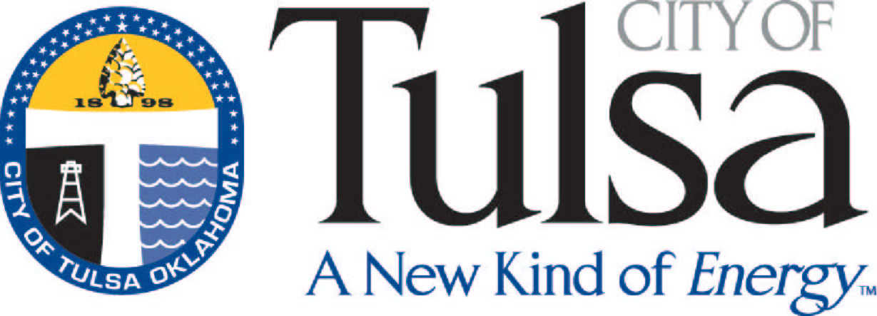
City of Tulsa
License Center
175 E. 2nd Street, Ste. 255
Tulsa, OK 74103
(918) 596-7640

How to apply for a Certificate of Compliance

A Certificate of Compliance is required by the ABLE Commission as part of the ABLE application. The documents required to issue a Compliance Certificate are as follows:

- Sales Tax Permit from the Oklahoma Tax Commission (918-581-2399)
- Certificate of Use and Occupancy (918-596-1847) **
- Completed application (attached)
- $35 processing fee

If NOT a sole proprietorship, the person signing the application MUST be either the President or a Vice President if a corporation, or the Manager of the Members if an LLC. If any other person signs, legal proof of power of attorney must be attached. The application must be notarized and not more than thirty (30) days old. The application and all required documents may be returned to City of Tulsa Business Licensing at the address above. It may be also be mailed to the following address:

City of Tulsa
ATTN: Finance Department
PO Box 451
Tulsa, OK 74101-0451

** If the Certificate of Occupancy has been applied for but has not been issued yet, please submit the receipt showing that it has been paid for. A temporary Compliance Certificate may be provided until the Certificate of Occupancy is issued. The ABLE Commission will not issue the ABLE license until they have received the final Compliance Certificate, but they will start the paperwork on the establishment upon receipt of the temporary.

City of Tulsa
License Center
175 E. 2nd Street, Ste. 255
(918) 596-7640

Certificate of Compliance Application

I, the undersigned as owner or proper agent, request that the City of Tulsa verify that my business, which is involved in the sale of alcoholic beverages, is in compliance with all City of Tulsa’s applicable zoning, fire, safety and health codes, as well as not delinquent with any local or state taxes. This request is submitted in order that I may obtain the Certificate of Compliance (as referenced below) to attach my application to be submitted to the ABLE Commission. (Please note: Liquor Stores (Package Stores) must be owned by an individual. They cannot be owned by a corporation, LLC, etc.)

Establishment DBA Name: ____________________________________________
Business Owner Name: ______________________________________________
Type of Business:___________________________________________________
Sole Proprietorship, Partnership, Corporation, LLC, etc.
Establishment Address: ______________________________________________
Including Zip Code
Contact Person & Phone Number: ______________________________________
Type of ABLE License applying for: _____________________________________
(Beer & Wine, Beer Distributor, Bonded Warehouse, Caterer, Mixed Beverage, Mixed Beverage/Catering Combo, Retail Beer, Retail Wine, Package Store, Wholesaler, etc.)

__________________________________________ _____________________
Signature of owner or proper agent Date

Subscribed and sworn to before me this _______ day of __________________, 20____.

______________________________________________ _______________________
Notary Public & Commission Number My Commission Expires

