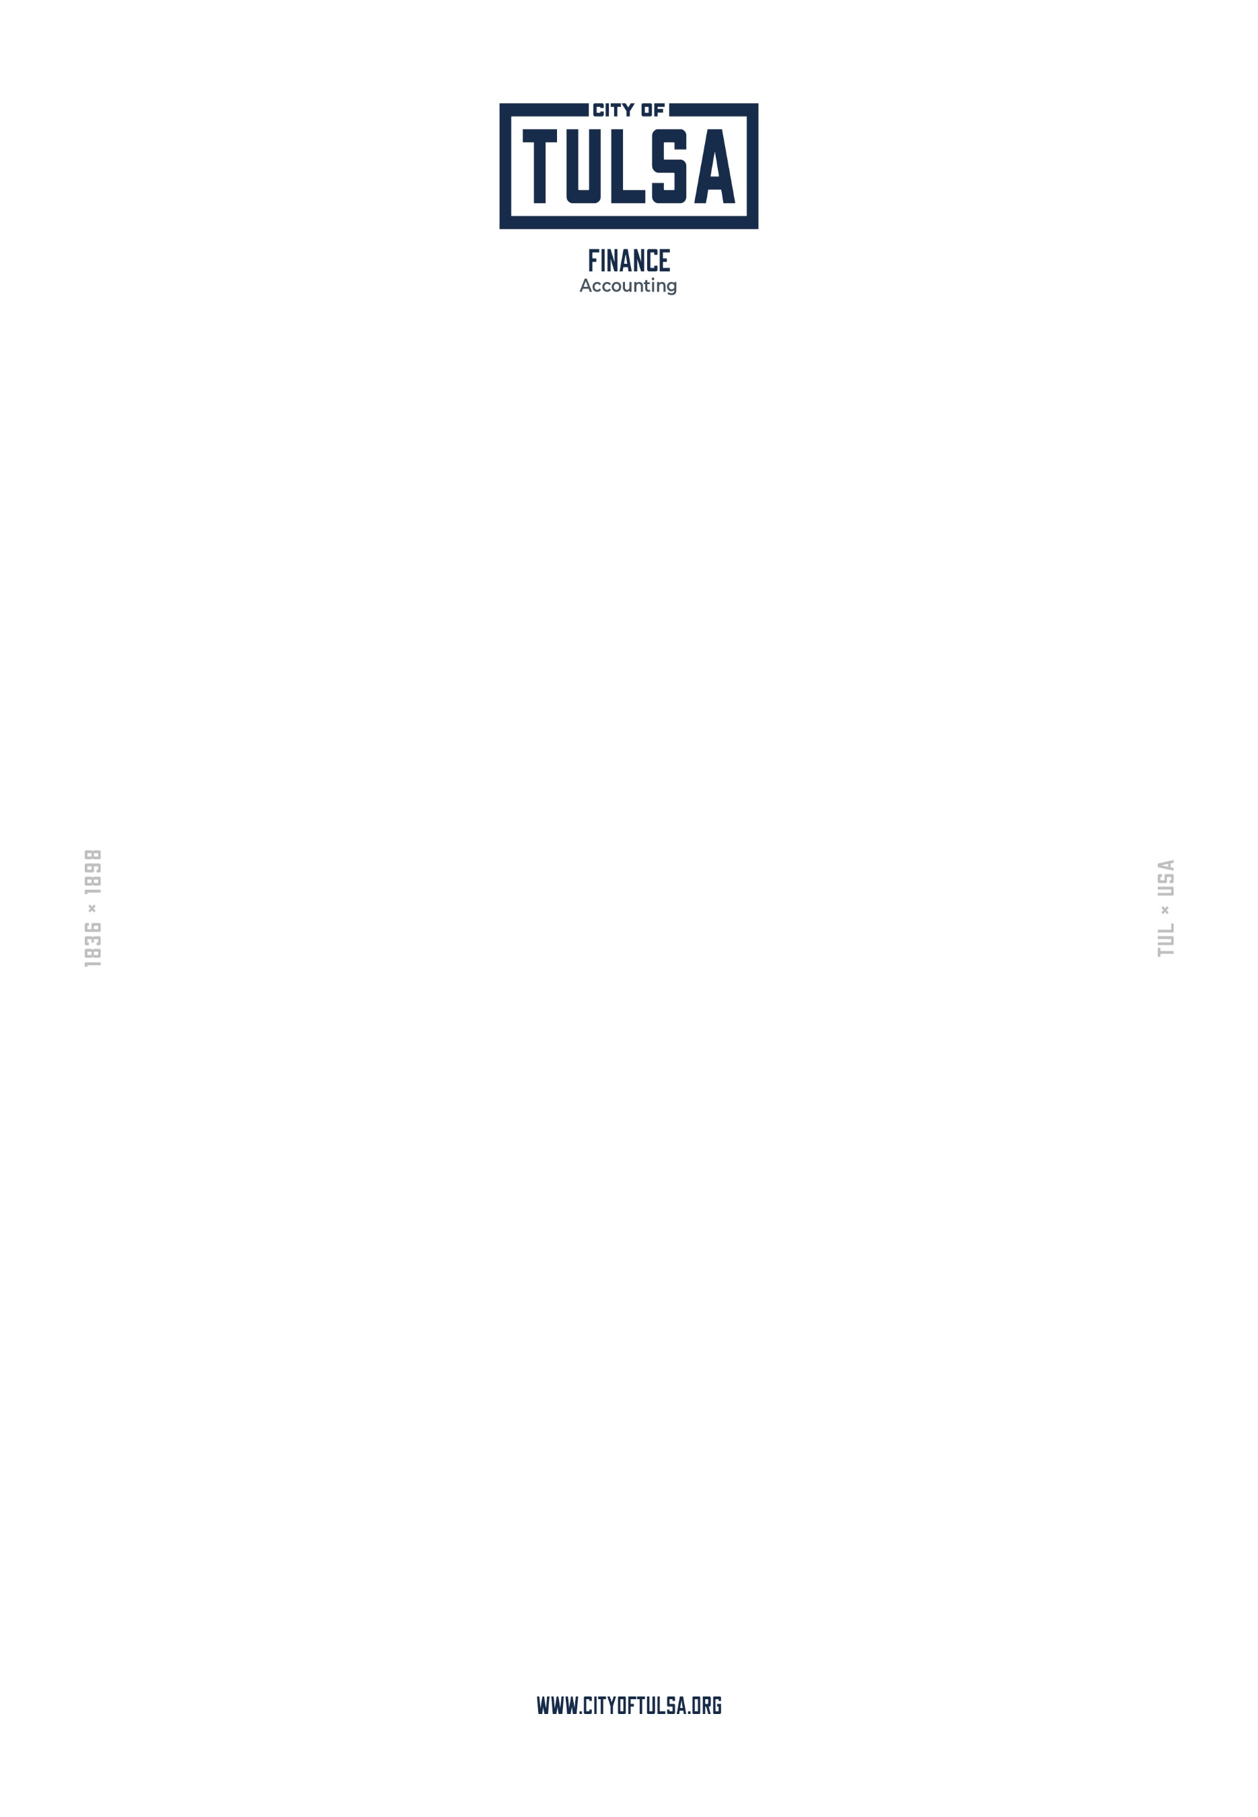

Request to Donate Sick Leave
**(for non-sworn use only)**

First Name Last Name

Employee Number Department

Number of Hours Requested Effective Date

I certify that this request does not take my sick leave balance below 960 hours and is in compliance with any other policies and collective bargaining agreements regarding sick leave donations.

Signature Date

Return signed form to: Central Payroll, 175 E 2nd Street, Suite 575, Tulsa, OK 74103
***For Non-Sworn Employees Only***

