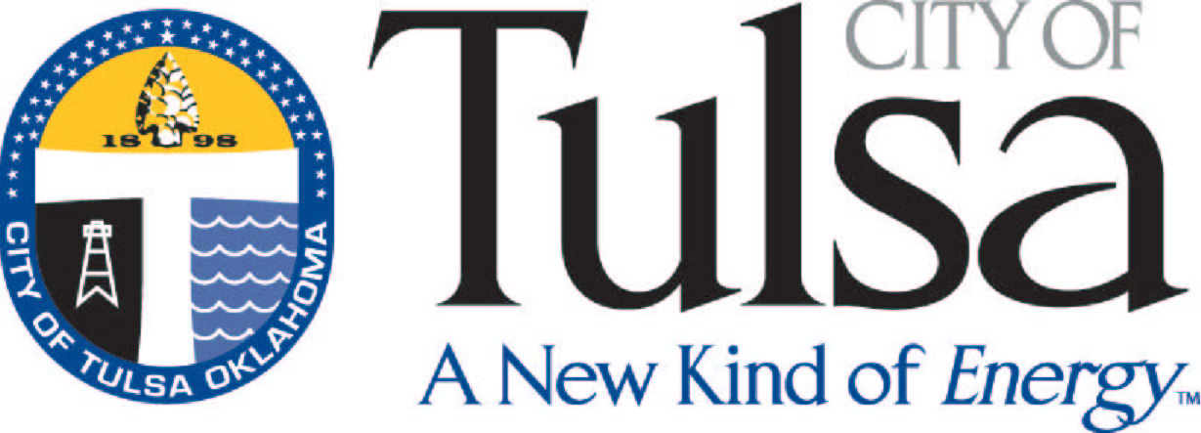
City of Tulsa
License Center
175 E. 2nd Street, Ste. 255
Tulsa, OK 74103
(918) 596-7640

How to apply for a Sexually-Oriented Business license

- Complete the attached form. Please correctly identify the type of license being applied for. Definitions of categories are in Section 1701(G) of the Sexually-Oriented Business ordinance.

- The following must also be submitted:
  - A scale diagram of the establishment. If the establishment is an Adult Motion Picture Arcade, the diagram must include the locations of one or more managers’ stations and all overhead lighting fixtures. It must also indicate any areas where patrons are not permitted. Please review Section 1714 of the Sexually-Oriented Business ordinance for requirements
  - A copy of the establishment’s State of Oklahoma sales tax permit
  - An updated Certificate of Use and Occupancy (including total floor space occupied) – please call 596-1847 for questions concerning this

- No money is due when the application is submitted. If the application is approved, the applicable license fee is then due. The license fees are $400.00 except in the case of an Adult Motion Picture Arcade, which is $500.00.

- Within 30 days of receipt of a completed application, a decision will be made to grant or deny the license. The applicant will be contacted either by telephone or mail.
City of Tulsa
License Center
175 E. 2nd Street, Ste. 255
(918) 596-7640

Sexually-Oriented Business Application
(Please type or print legibly)

Type of license applied for:
- Adult Amusement or Entertainment
- Sexual Encounter Center
- Adult Bookstore
- Adult Motion Picture Theater
- Adult Mini Motion Picture Theater
- Adult Motion Picture Arcade

Name of Business | Date
Business Address ZIP | Business Phone
Legal Description
Business Type (corporation, partnership, sole proprietorship, LLC, etc.) | Name of Contact Person

In addition to this completed form, please submit the following:

- A scale diagram of the establishment, including statement of total floor space occupied
- A copy of the establishment’s State of Oklahoma sales tax permit
- An updated zoning clearance permit (Certificate of Use and Occupancy) – please call 596-1847 for questions concerning this.

City of Tulsa
License Center
175 E. 2nd Street, Ste. 255
(918) 596-7640

Sexually-Oriented Business Applicant Information
(Please type or print legibly)
If business is corporation, partnership or LLC, every partner or officer must complete this application to include their personal information.
Name: First Middle Last Date of Birth | Social Sec. Number
Home Address ZIP | Home Phone
Mailing Address (if different) ZIP | Other Phone
Home Addresses for Previous five (5) years:

Please answer by initialing the following questions:

Have you ever been employed in a sexually-oriented business in a managerial capacity?
_______ yes
_______ no

Are you overdue in payment to the City of Tulsa or State of Oklahoma for taxes, fees, fines of penalties assessed against or imposed upon you in relation to a sexually-oriented business?
_______ yes
_______ no
If yes, please explain: ______________________________________
________________________________________________________

Have you been convicted of a violation of a provision of Title 21, section 17 (the Sexually-Oriented Business ordinance) in the past two (2) years?
_______ yes
_______ no
If yes, please explain: ______________________________________
________________________________________________________
Have you been charged, arrested, convicted or released from confinement for any of the following crimes, or of criminal attempt, conspiracy or solicitation of the same, in the past five (5) years? (If you have been convicted of a crime and are unsure whether it is one listed, answer yes.)

- Indecent exposure
- Indecent exhibitions
- Obscene or indecent writings, pictures, etc.
- Solicitation of minors to participate in indecent exhibitions
- Solicitation of minors to participate in obscene or indecent writings, pictures, etc.
- Consent to participation of minors in obscene writings, pictures, etc.
- Buying, selling or delivering into Oklahoma any material showing acts of sexual intercourse or unnatural copulation
- Procurement of a minor for prostitution
- Restraining a minor for prostitution
- Rape by instrumentation
- Rape
- Sexual battery
- Aiding, abetting or harboring a runaway child
- Outraging public decency
- Operating a place of prostitution
- Receiving or transporting for the purpose of prostitution
- Procuring or soliciting for the purpose of prostitution
- Engaging in prostitution
- Engaging in lewdness
- Exposing minors to harmful materials
- Disclosure of obscene materials containing minors
- Publication, distribution or participation in preparation of any obscene material or presentation through unsolicited mailings
- Permitting pandering on premises
- Permitting restraint of minor for prostitution on premises

_______ yes
_______ no

If yes, please explain the circumstances for each conviction, giving the dates of conviction (and release of confinement, if applicable), the city and state where such conviction occurred, and whether such conviction was for a felony or a misdemeanor: _____________________________________________________
____________________________________________________________________________________________________________________________________________________________________________________________________________________________________________________________________

City of Tulsa
License Center
175 E. 2nd Street, Ste. 255
(918) 596-7640

Sexually-Oriented Business Affidavit

I, __________________________________________, being duly sworn and of lawful age, attest that the foregoing information is true and correct and that all appropriate parties have completed it.

_______________________________________________
Signature of Applicant

_______________________________________________
Title (if Applicable)

State of Oklahoma
County of ____________

Signed and sworn to before me on this ___ day of ____________, 20___.

__________________________________________ _________________
Notary Public Commission Number

My commission expires: _______________________
FOR CITY OF TULSA OFFICE USE ONLY

Department of Finance:

Received by License Center and approved as complete:

_________ ____________________________________
Date License and Collections Manager (or approved representative)

Received by Revenue Collections and approved as to compliance with Section 1704 (A):

_________ ____________________________________
Date Revenue Collections Enforcement Administrator (or approved representative)

Police Department:

- Approved:
__________ ___________________________
Date Signature

- Denied
__________ ___________________________
Date Signature

Returned to License Center:

- License issued __________ ___________________________
Date License and Collections Manager (or representative)

- License denied __________ ___________________________
Date License and Collections Manager (or representative)

