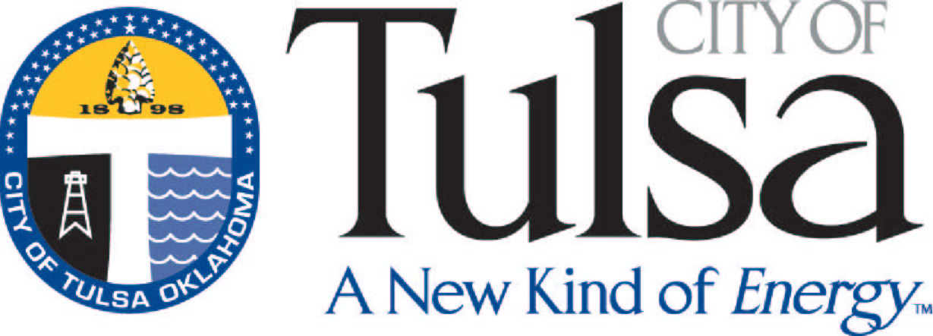
Treasury – License Center
Finance Department
175 E. 2nd Street, Ste. 255
PO Box 451
Tulsa, OK 74101-0451
(918) 596-7640

APPLICATION FOR PAWNBROKER PERMIT
(Expires October 1st)

(Circle one) New Renewal

DBA NAME: __________________________________
OWNER: __________________________________
CORP NAME: __________________________________

PHYSICAL ADDRESS OF BUSINESS

STREET: ___________________________________________________
ZIP: _______________ TELEPHONE: __________________________

MAILING ADDRESS

STREET: ___________________________________________________

CITY, STATE ZIP: ___________________________________________

NAME OF ON-SITE CONTACT: ________________________________

Signature of Applicant: _________________________________________

Date: ______/______/_______

PLEASE ENCLOSE THESE ITEMS WITH THE RENEWAL APPLICATION
- FEE FOR RENEWAL $50.00
- COPY OF OKLAHOMA PAWNBROKERS LICENSE*
- COPY OF OKLAHOMA SALES TAX PERMIT*

*Business information on the OK Pawnbrokers License,
OK Sales Tax Permit and this application MUST match.

