**Tulsa Citizen Self Service Registration Instructions**

You can access the Tulsa Citizen Self Service portal from <https://www.cityoftulsa.org/government/departments/development-services/permitting/>

Click on ‘Self Service Portal’; once you have the portal up, you can bookmark this address in your browser. If you have problems registering, please call 918-596-9456 or email [cotdevsvcs@cityoftulsa.org](mailto:cotdevsvcs@cityoftulsa.org)

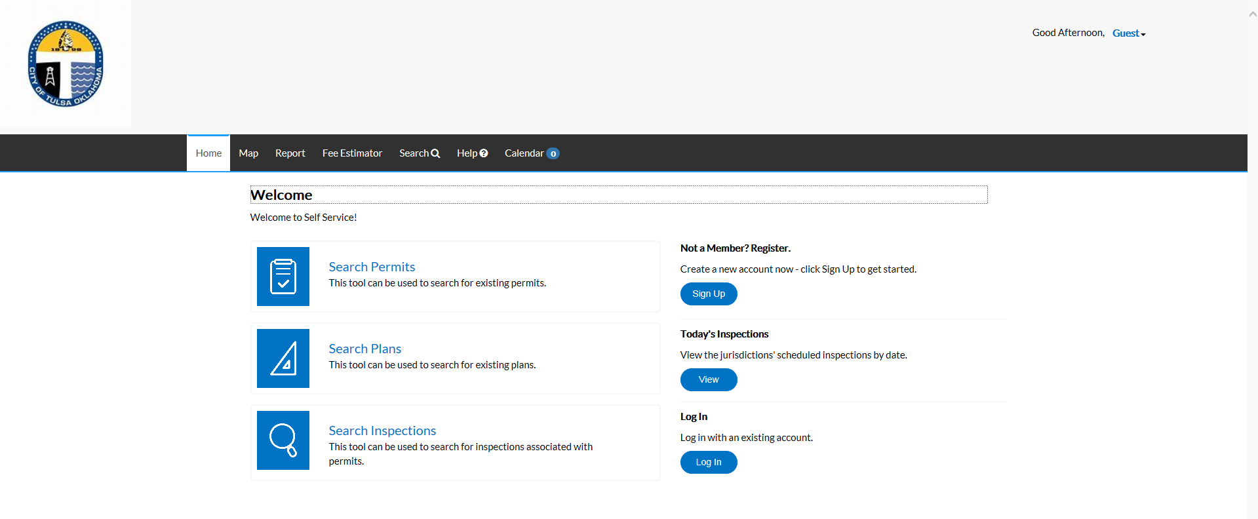

Anyone can browse the site as a guest without registering as a user. Those who have permits, plans, and other activities on which they are a contact with the City of Tulsa will want to register for the site to see more information regarding their project(s).

To register, go to ‘Not a Member? Register’ in the right hand column; click on ‘Sign Up’.



Follow the instructions on the screen to register.

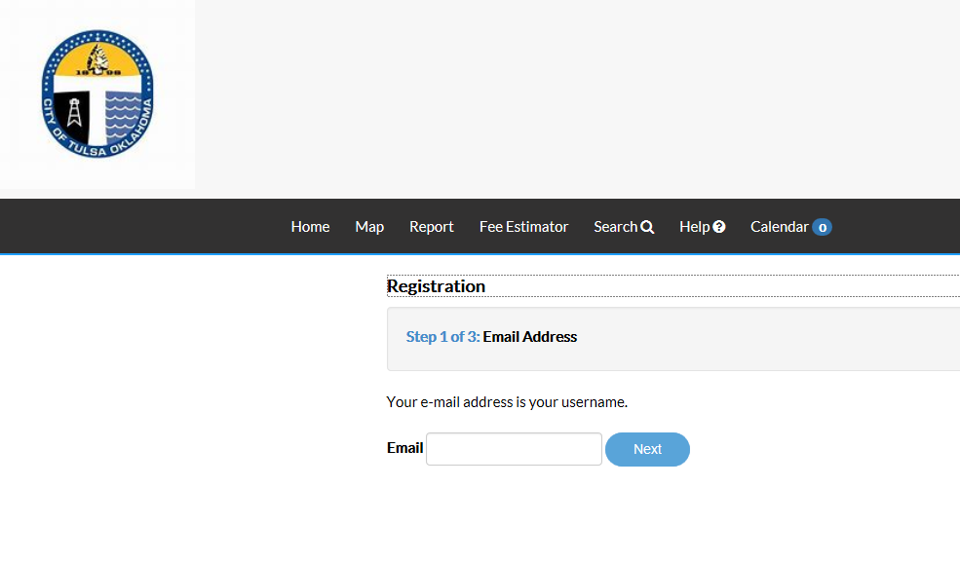

**NOTE: USE THE SAME EMAIL THAT YOU USE IN YOUR TRANSACTIONS WITH THE CITY OF TULSA TO ASSURE THAT YOU WILL BE ABLE TO SEE YOUR ACTIVITIES. FOR CONTRACTORS WHO ARE REGISTERED CONTRACTORS, THIS IS THE EMAIL ASSOCIATED WITH YOUR CONTRACTOR REGISTRATION. THIS WILL BE YOUR USER NAME.**

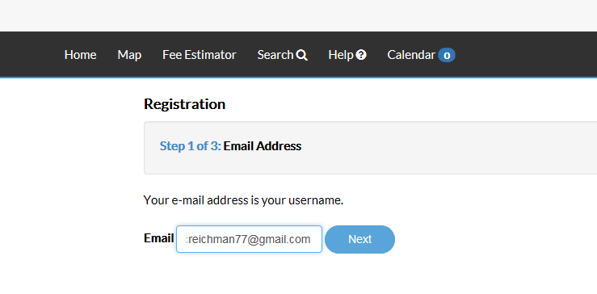

After you enter your email address, you will receive an email that contains a link to complete your registration. The email will be from [noreply@tylertech.com](mailto:noreply@tylertech.com)

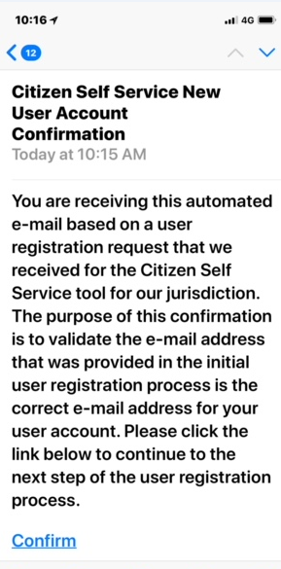

**NOTE: BE SURE TO USE THE CONFIRM LINK IN THE EMAIL TO COMPLETE THE REGISTRATION; DO NOT RETURN TO YOUR ORIGINAL REGISTRATION PAGE.**

Click Register to continue the registration process. You will only have to register one time.

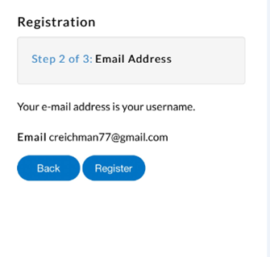

To complete the registration, you will need to provide some personal information. Only the fields that have red asterisks are required.

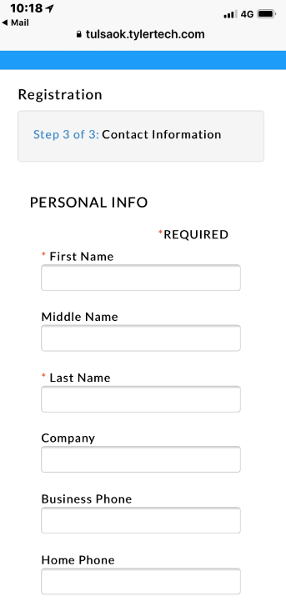

Most required fields are self-explanatory; however you will want to pay particular attention to the password. You get to pick your own password; the system will tell you the strength of the password. When you tab to “Confirm Password,” the system will tell you “Password and confirmed password do not match.” Ignore this message and continue to type your password into the blank confirm password field. Once you have entered your password into the confirm password field, the message will go away if the passwords match.

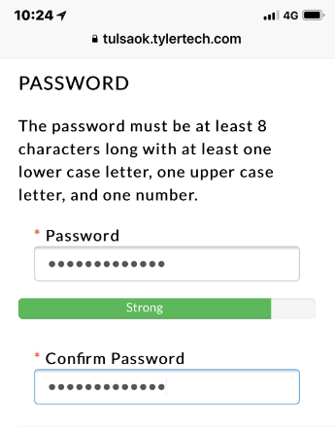

At the end of the process, click the “I am not a robot” button and submit your registration.

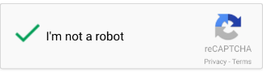

You will receive the following message at the end of the process.

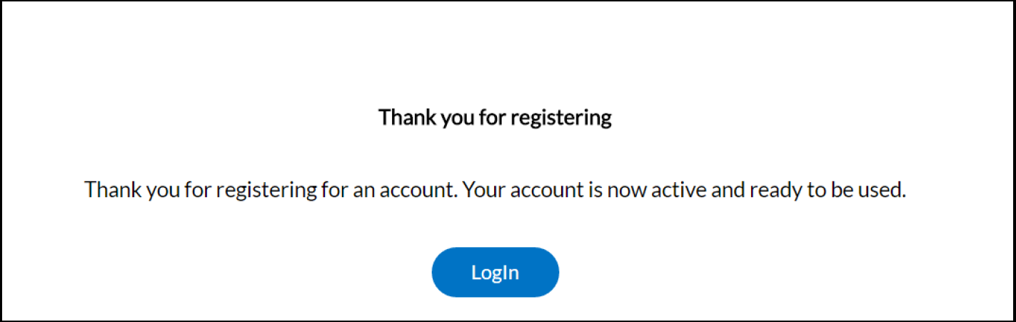

To login, you can click on the Login button on the Thank you for registering screen. If you are a returning customer, you can click on Log in on the home page.



Enter your email address and password; click Log in.

